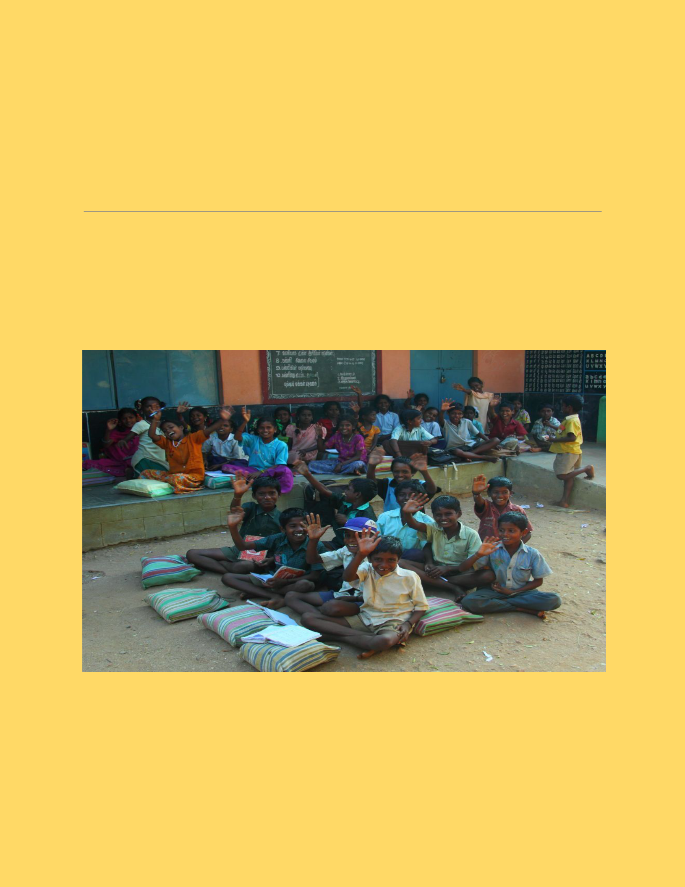***WEB APPLICATION***

***DEVELOPMENT***

***TITLE: Walk with a Book***

1



* ***Project Motivation:***

The main motivation of the project is to help the poor by giving books for free.The primary focus will be to help the poor,but it will also be helpful to other people as well.

* ***Problem Statement:***

In these present situations, it is difficult for poor people to even afford food,thus affording money for buying books has become a big burden for their child's education!!

* ***Problem Solution:***

This website will play a major role in giving books to the poor for free which will be very helpful for them.

2



* ***Functional Description: Total Modules : 8***
* ***Module 1-Blueprint:*** *​*We will firstcreate a blueprint of our website on a paper.
* ***Module 2-Web Design:*** *​*We will startdesigning our website using HTML, CSS and JS and Python for Home page (front end).
* ***Module 3-Prototype:****​​*We will designa login pop up window and after logging in, the user will find​​options in the page (Donate books/Buy books/Hall of fame).
* ***Module 4-Client Needs:*** *​On**choosing :*

3

* ***“****​****Buy****​​****books****​****”****​will redirect to a**page where there will be a book shelf along with a filter and a search bar. So, the user can select the desired books and add them to the cart.*
* *“​****Donate****​​****books****​” will redirect to a page where the donors should fill up the details like the name and address.*
* *“​****Hall****​​****of****​​****Fame****​” will redirect to a page where top donors are listed in leader-board with the number of books donated and can search donors by their donation ID.*

4



* ***Module 5-Database management:*** *By using MongoDB,we will connect to*

*the database and maintain user records.*

* ***Module 6-Tracking:****​*​In this module,we will have a payment gateway and order tracking.
* ***Module 7-Testing:*** *​*We will test ourwebsite for 2-3 weeks before deploying.
* ***Module 8-Deployment:*** *​This is the**last stage, where we will deploy and maintain the website with improvements and no bugs.*

5



* ***Project Overall Idea:*** *​*People whowant to donate their books can login to this website and can fill in the details of the book like name,genre and condition of the book. If the book is in good condition to read,then he has to give his address and then a pick up guy comes to receive it. Donors get the points or coupons which will be helpful to buy books from a website with low cost!! The book will be posted on the website with title, edition, proper photo and grade of the book. Customers who are interested in that book can place an order with only delivery charges and order will be received as soon as possible and customers can keep track of order and

6

can contact customer care for any further queries and updates.

* ***Group No:*** *​****30***
* ***Group Leader:***

​*Anirudh Jakhotia*

* ***Group members:*** *●Neeraj Dusa ●Harish Mullagura ●Rakesh Ganeshula ●Jayanth Sri Ram Kanduri*
* ***Duration:****​*​*6-7 hours per week*

7

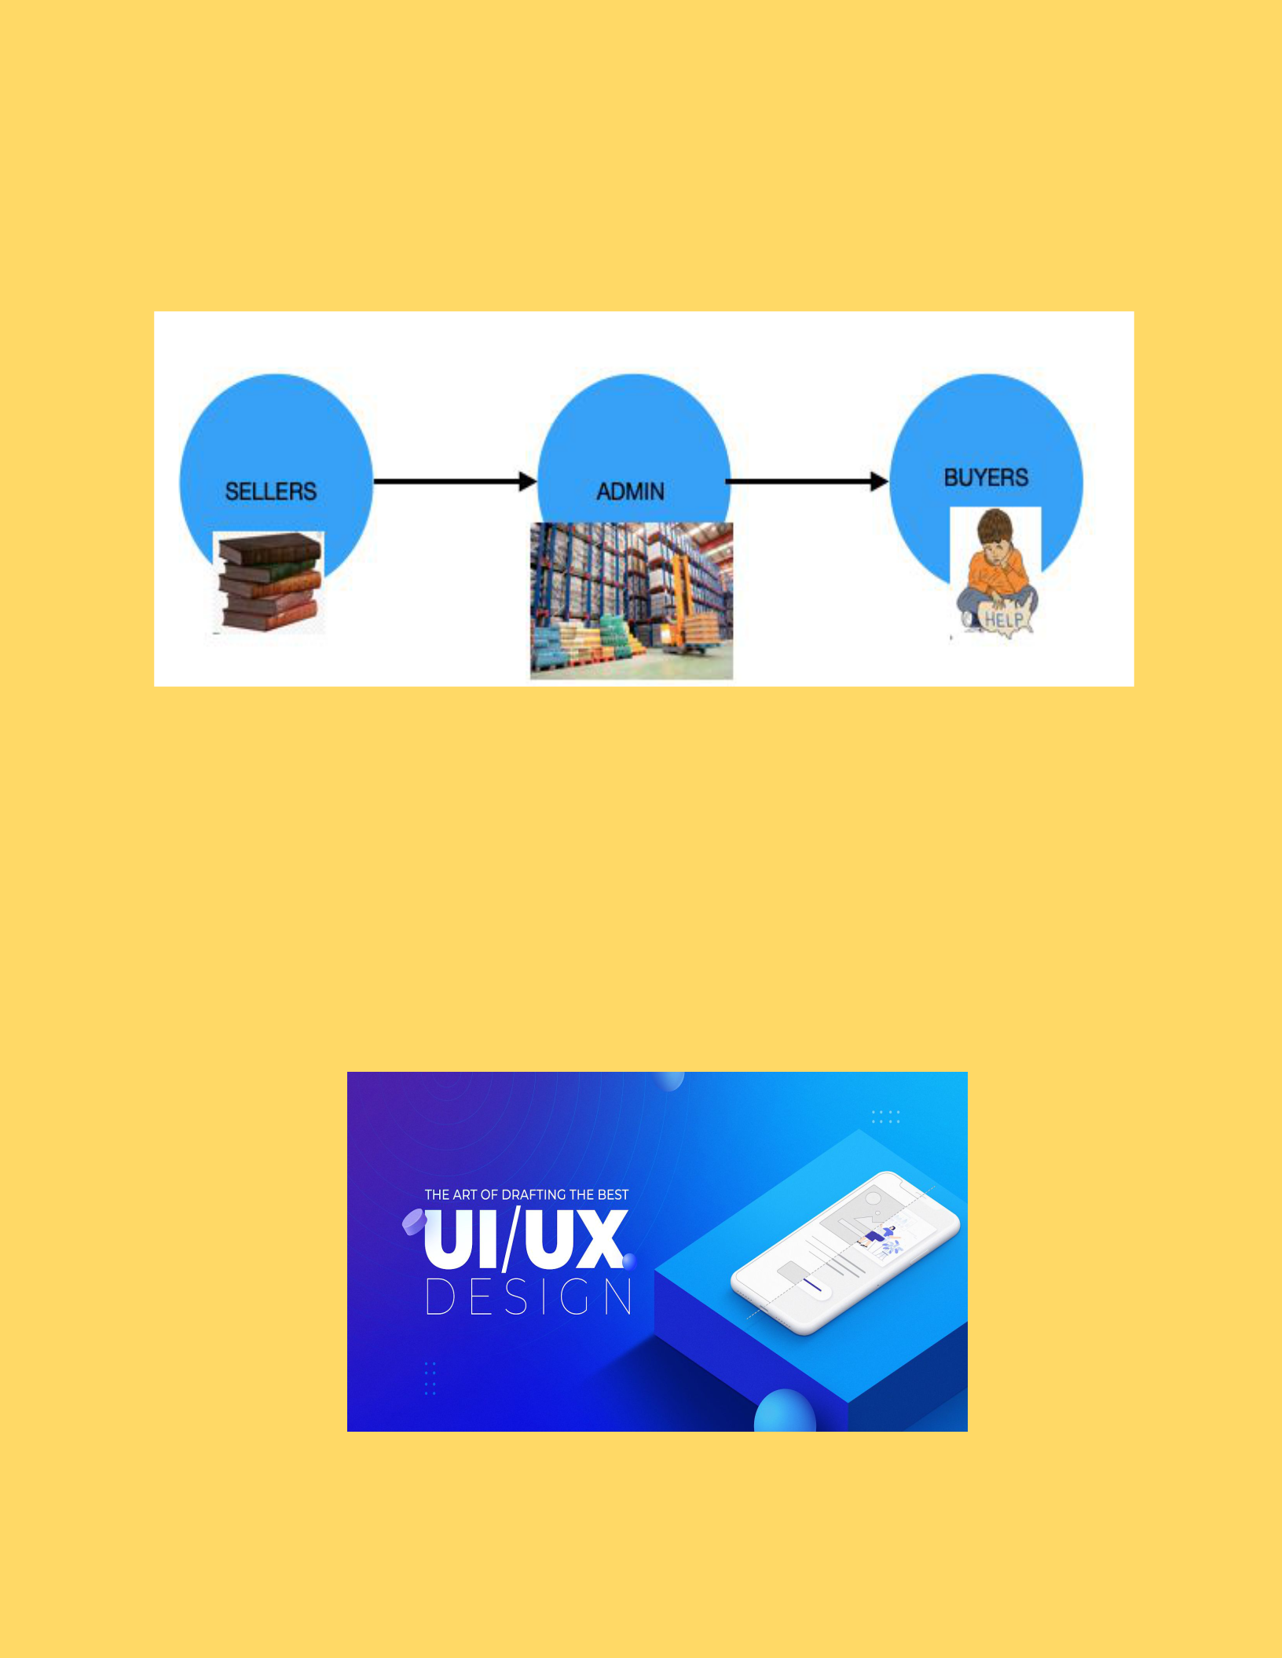

***Primary Blueprint Of Our Idea***

***FEATURES***

* ***Better UI / UX***

8

* 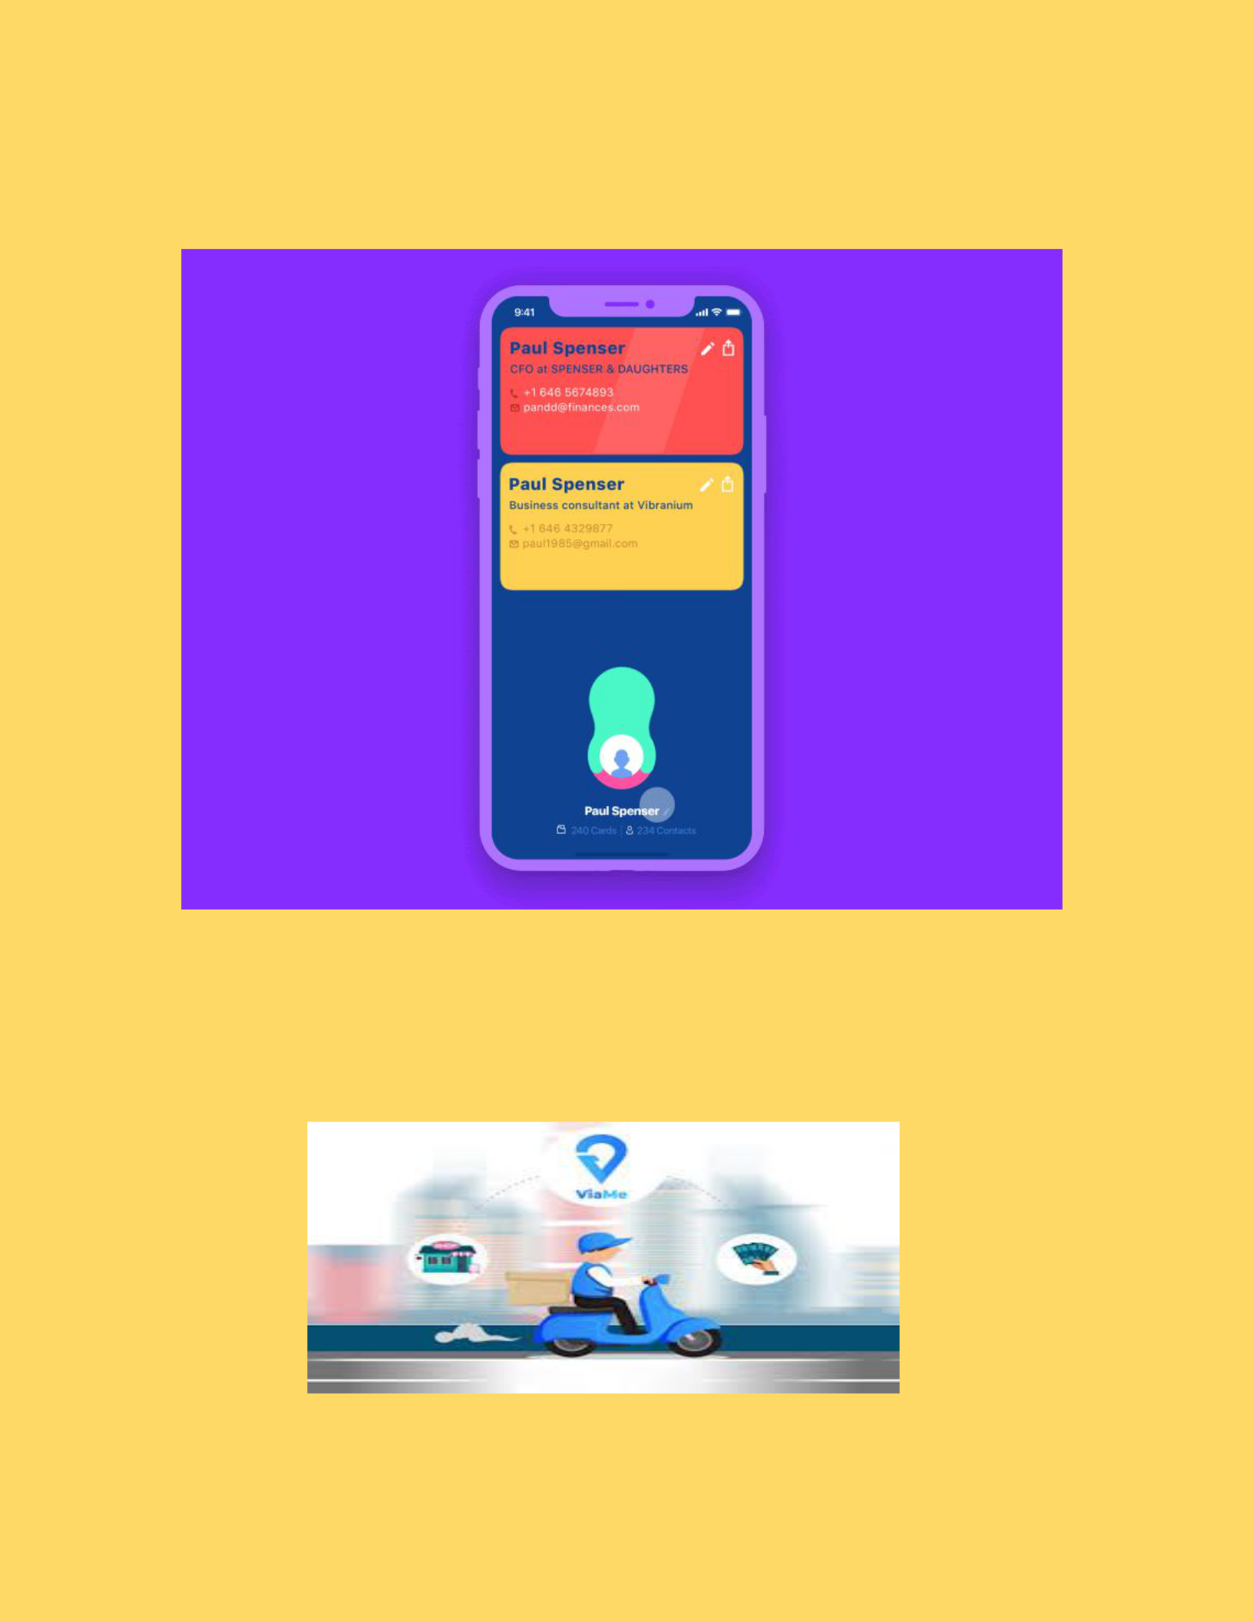***Easy Usage***
* ***Cash on Delivery***

*​*

9

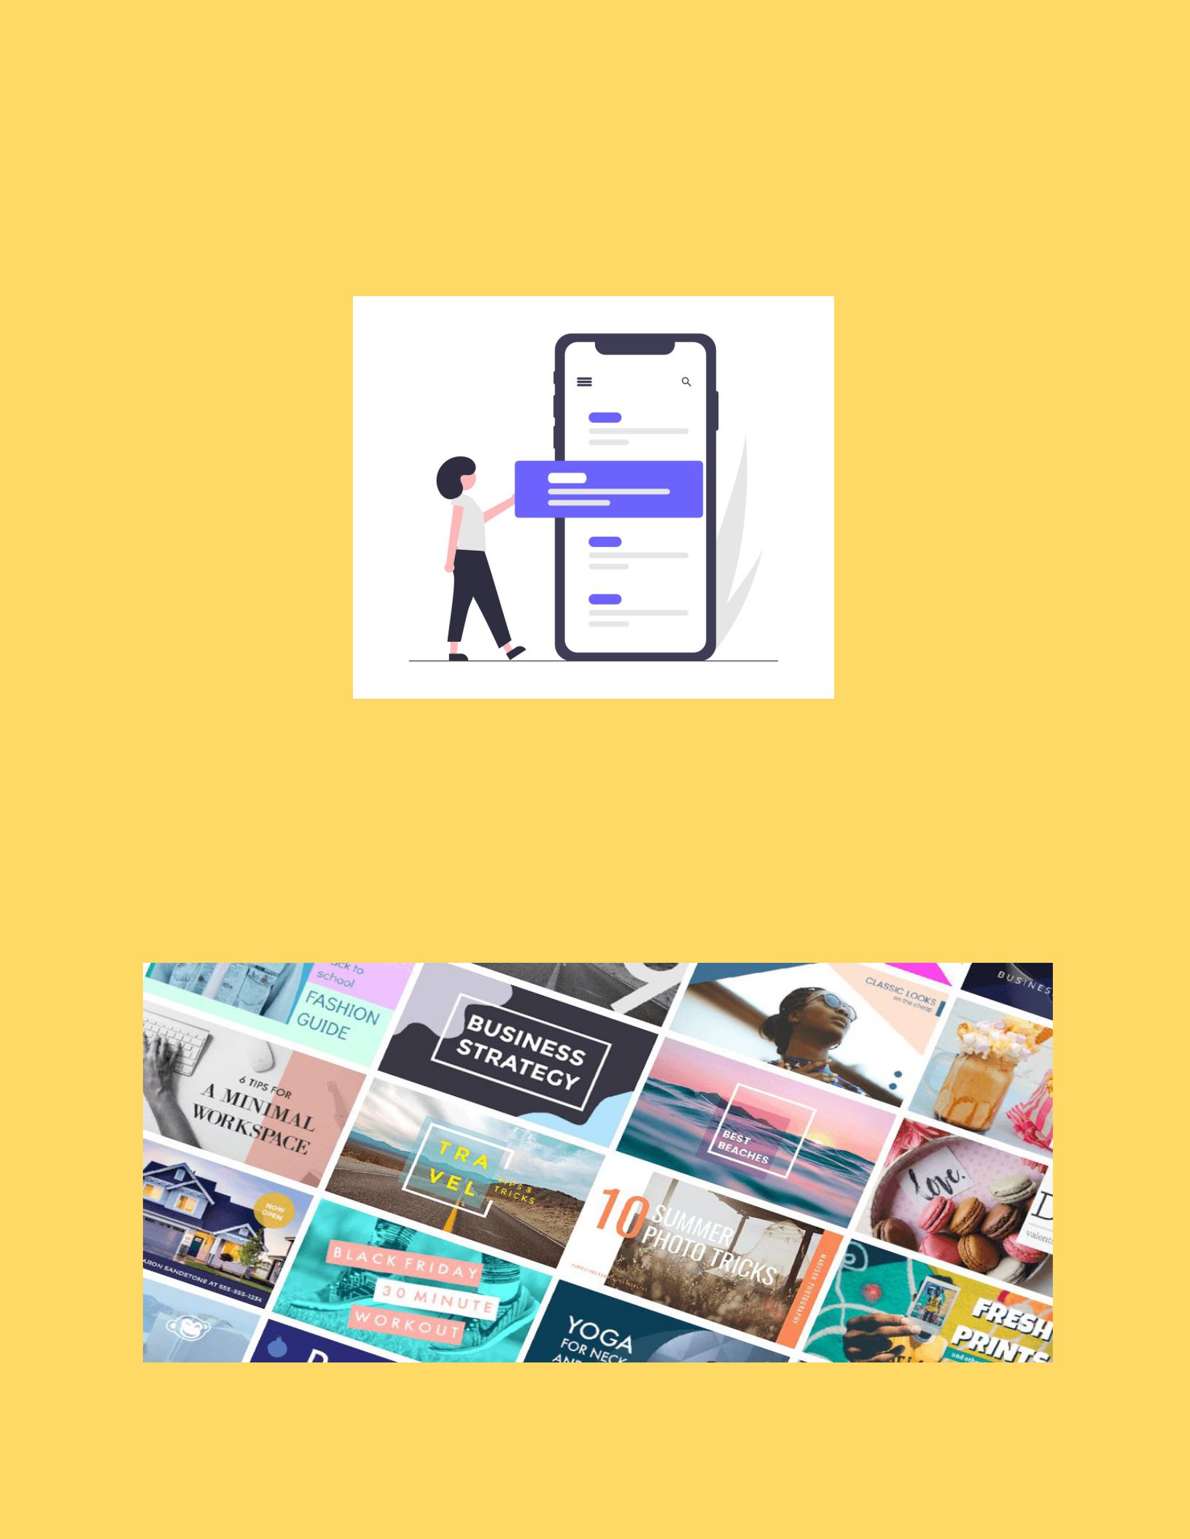

* ***Clean navigational menu with an In-Site Search and product categories.***
* ***Good quality product photos with image zoom and thumbnails***

10

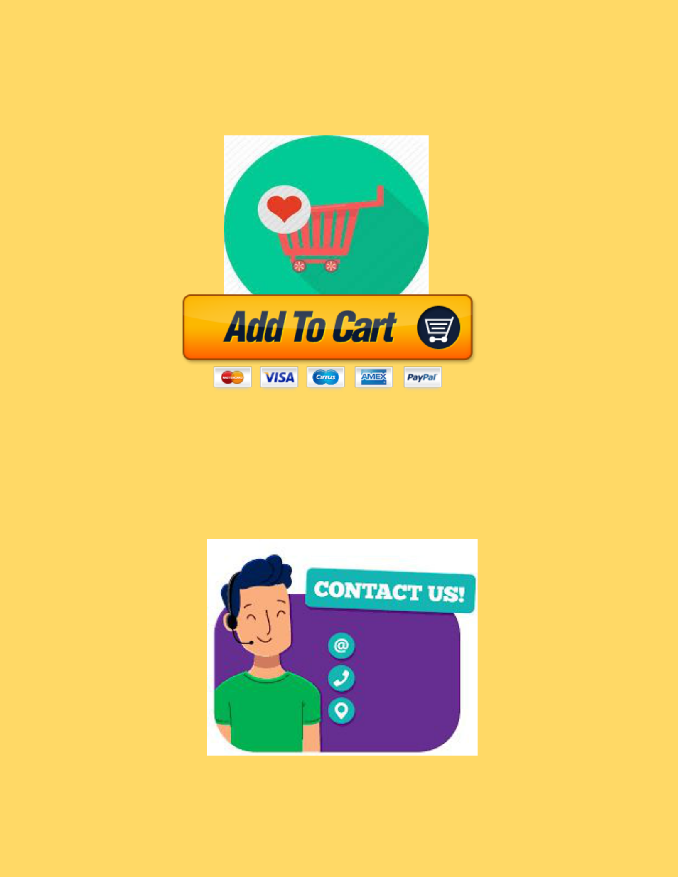

* ***Wish-list and Add to cart***
* ***Engaging and informative “About Us” page with contact details.***

11

* ***Social media connections***
* ***Suggestions and user feedback is taken***

12

* 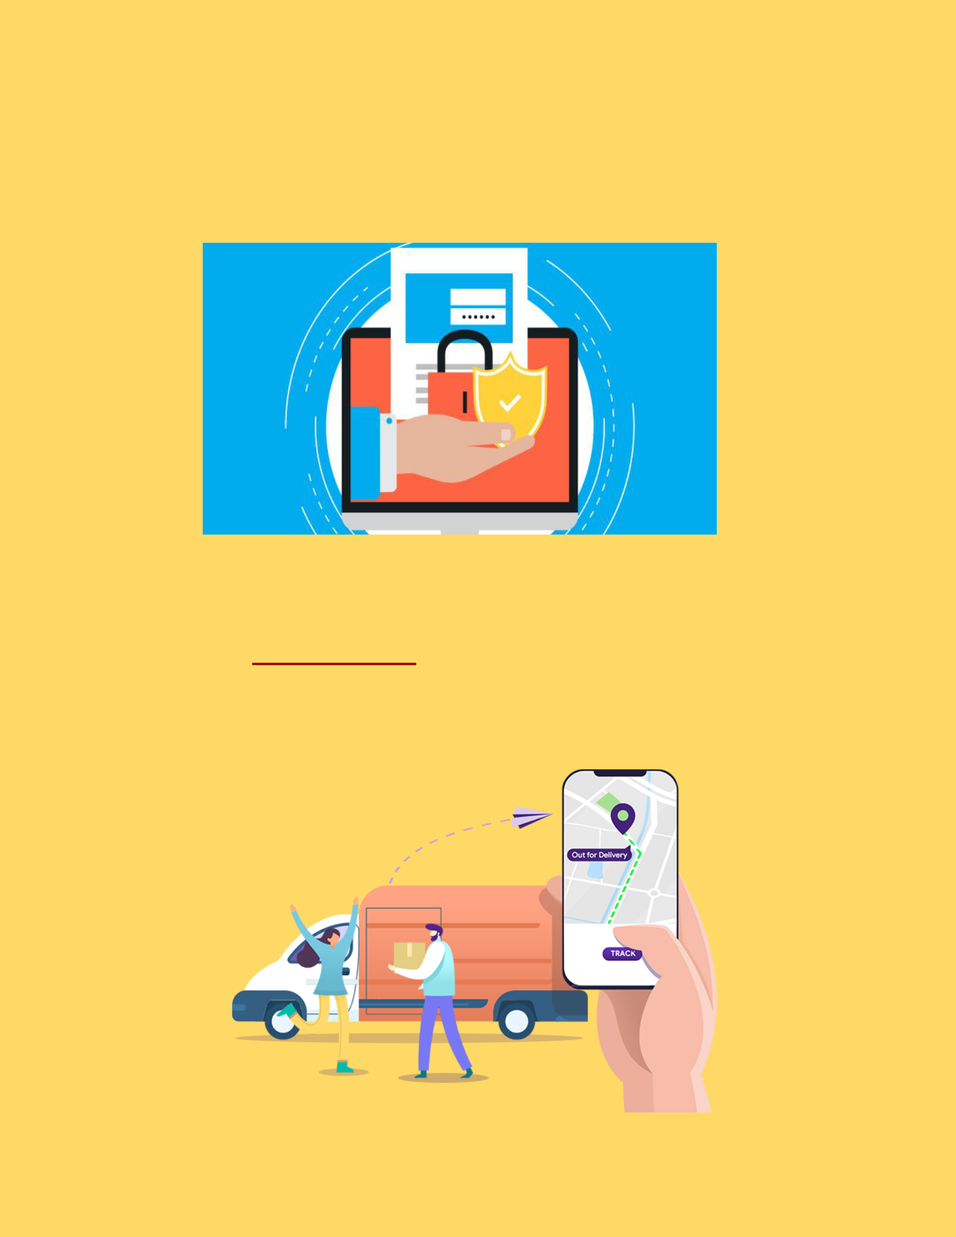***Secure Login and User information is safe***

***Further ​Updates​ :***

* ***Tracking option for orders.***

13



* ***E-Payment***
* ***Bug fixes and performance improvements***

14



* ***Discount offers and coupons for Donors***
* ***Will soon provide other products along with books***

15

***Connectivity***

* **Hall of fame :**

**The top 15 donors are posted in the Hall of Fame with their Name,photo and Contact information.**

16



* ***Delivery can be reached for various possible places of India***
* **Sending email to Others**

**Can send a direct email for others to check about the website and can suggest a book and can interact with the Donors.**

17



* **QNA Queries**

**For any queries about the books and other details can ask questions and will be replied soon**

18

***Work Assigned***

***Anirudh Jakhotia :*** *​Graphic Designer**and Security*

***Neeraj Dusa :*** *​Information Gathering and**Catalogue management*

***Harish Mullagura :****​Database management**and Tracking*

***Rakesh Ganeshula*** *​:**​Website Developer*

*and payment​ gateway*

***Jayanth Sri Ram Kanduri :*** *​UI/UX*

*Designer, Manages bug fixes and improvement.*

19

***Software Components :***

* ***HTML,CSS,JS,Python,Django,Bootstrap, MongoDB Editor - VS Code***
* ***Web Browser - Google Chrome***
* ***Graphics Editor - GIMP,Adobe Photoshop***
* ***FTP Client - Filezilla***
* ***New Software components to be added for further development.***

***Preliminary work :***

20